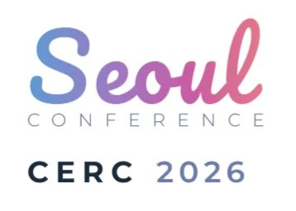
4th International Care Ethics Research Consortium Conference
June 25-27, 2026 | Korea University, Seoul
ibis Ambassador Seoul Insadong
ROOM RESERVATION FORM
Please send this form to secure your reservation
TEL: +82 2 6730 1101 | E-MAIL (TO): ibisissm4@ambatel.com | E-MAIL (CC): ibisisres@ambatel.com
ROOM INFORMATION
Room Type | Weekday Rate (Sun-Thu) / Weekend Rate (Fri, Sat, Holidays) | Select
Superior Twin Room  (Max 2 guests) | Please refer to the individual announcement email for specific weekday and weekend rates. | ☐
Superior Double Room  (Max 2 guests) |  | ☐
Rate Information:
• Rates are breakfast exclusive and subject to 10% VAT
• Breakfast charge: KRW 14,300 (tax inclusive)
GUEST INFORMATION
Last Name (Family) |  | Accor Membership:  ☐ Yes ☐ No
First Name (Given) |  | Accor Membership:  ☐ Yes ☐ No
Nationality
Phone |  | Fax
E-mail
STAY DETAILS
Check-in Date |  | Check-out Date
Special Requests

CREDIT CARD GUARANTEE
Card Type | ☐ VISA ☐ MasterCard ☐ American Express ☐ Diners Club
Card Number
Expiry Date | MM / YY
IMPORTANT INFORMATION
Reservation Cut-off
Reservations received after the cut-off date of 1st April 2026, could be offered at a different rate upon hotel availability.

Cancellation Policy
• Free cancellation & changes are permitted up to 14 days prior to check-in date
• Cancellations within 13 days of check-in or no-shows will incur a 100% cancellation fee

Hotel Policies
• Check-in: After 14:00 | Check-out: Before 12:00 (Early check-in and late check-out not allowed)
• Mechanical parking tower: 22 spaces / Outdoor parking: 3 spaces (including 1 for disabled parking) are available. Parking fee: KRW 22,000 (separate charge). Parking is not available when full.
AUTHORIZATION
By signing below, I authorize the above reservation request and agree to the stated policies.
Signature | Date

